Midterm project report

M11225007孫詳恩

1. Extract red point from image

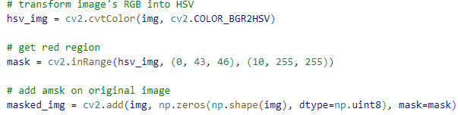

First, transform image from RGB to HSV, and set the HSV index to show only red point. Finally put a mask on the image to transform image to black, except the red point. Show as fig.1

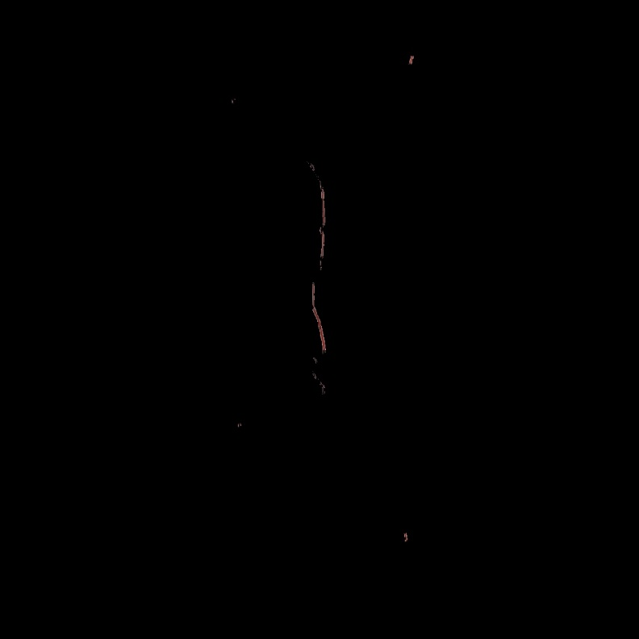

Fig. 1 Extracted red point

1. Store red point’ coordinates

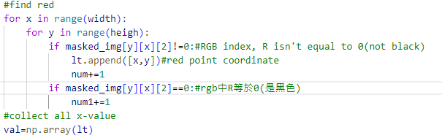

If in RGB of image, Red not equal to 0, then store it, or if equal to 0, it the black region.

1. Find corner of red point.

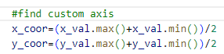

We need to find the Homography matrix, in this project, we design a function can find the corner of all red point, and calculate with the coordinates we want to convert. So we define a custom axis, the concept is showing in fig. 2.



Y-axis

X-axis

Fig. 2 concept

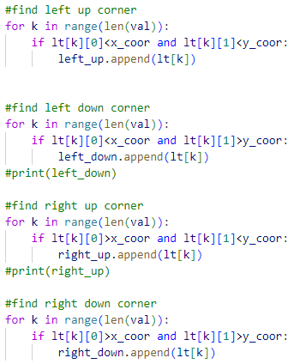

With the axis, we can write some function to find the corner, the axis will cut the image to four region, we named left up, right up, right down and left down, each region has different condition to distinguish the corner. For example, to find the right up corner, the first step is find the point’s with x and y coordinate is bigger than x-axis and y-axis, the extract the last point, so that we can find the corner point of right up region.

1. Calculate Homography matrix

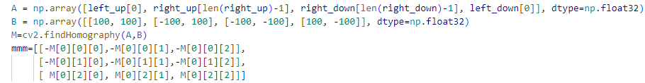

After we get the four corner point, we can calculate the Homography matrix, by using the inner function code cv2.findHomography(), we can easily get the Homography matrix, and convert every red point to 3D coordinate b y Homography matrix.